Practical-7

|  |  |
| --- | --- |
| **TASK :** | **Login into CloudxLab and Open Ambari and check your server status and other configurations available.** |

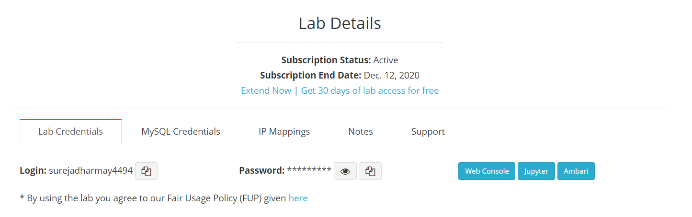

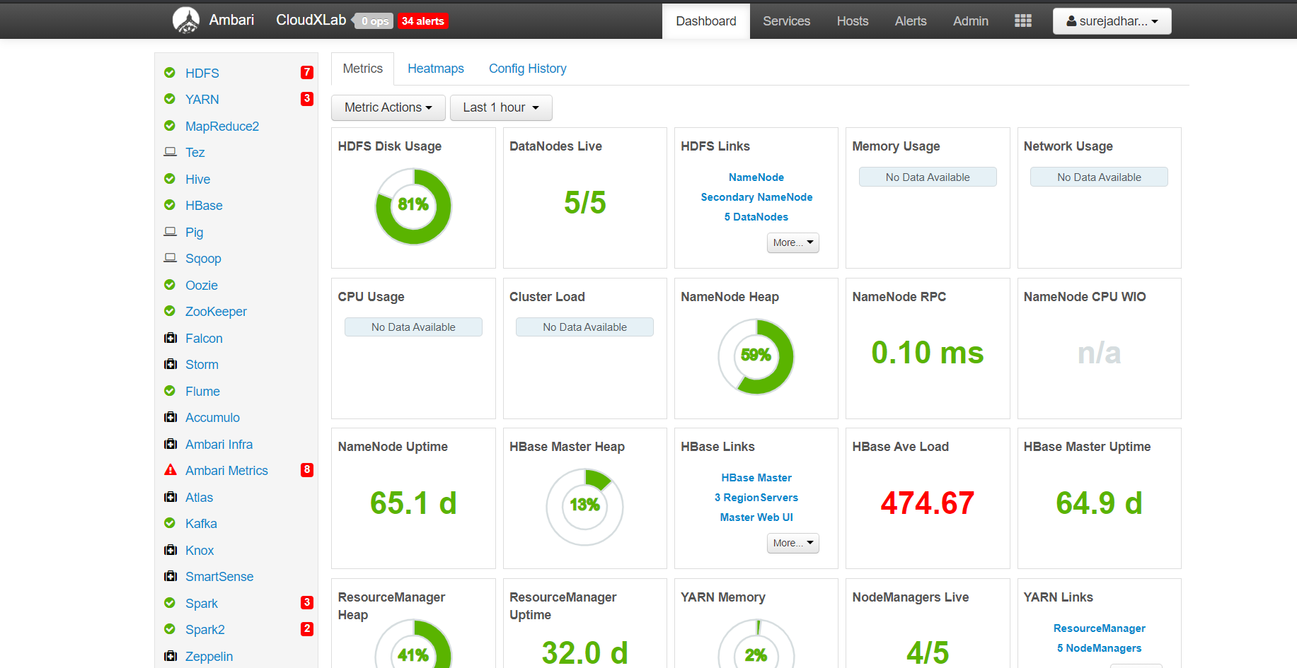

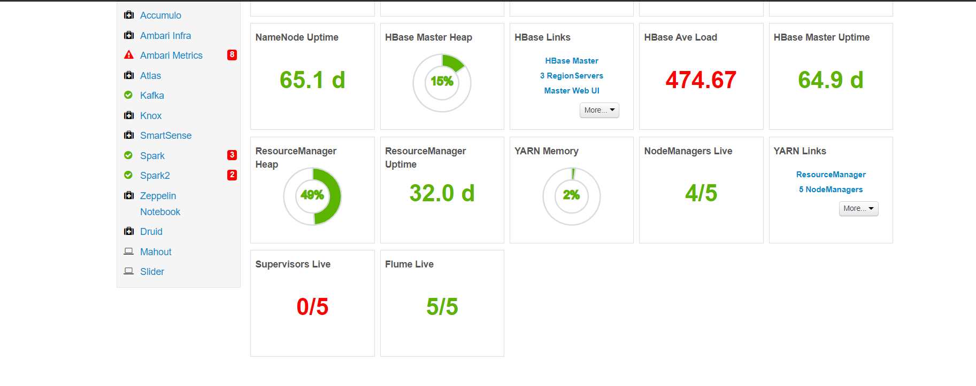

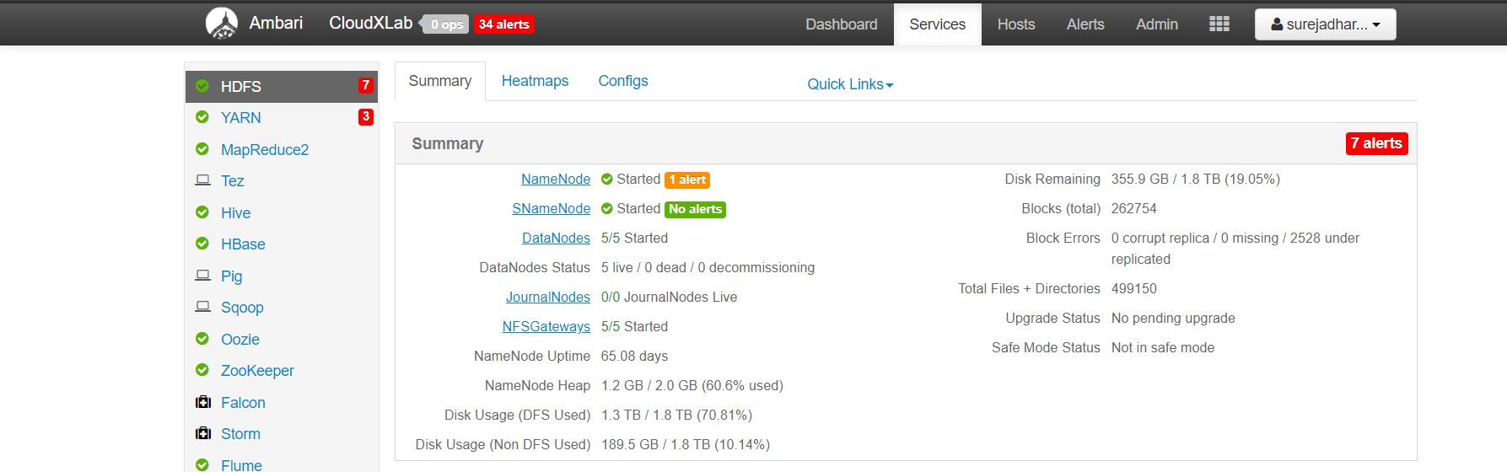

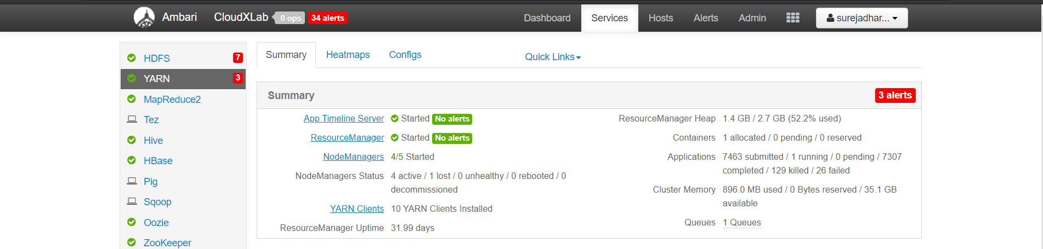

**TASK :- Using CloudxLab Linux Console .**

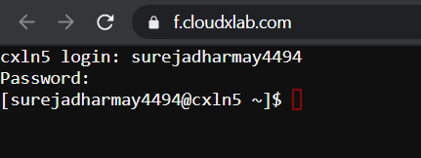

1. Create File and save some content in it.

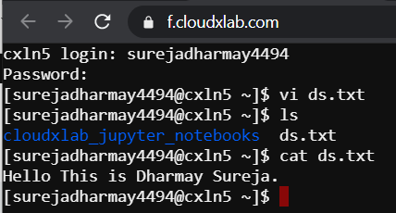

1. Transfer it into the HDFS.



1. Verify if it is available in HDFS.

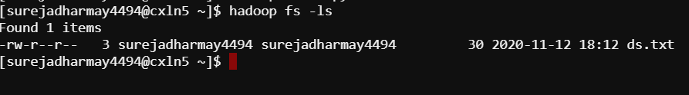

1. Check the Content of the file (Display it on screen)

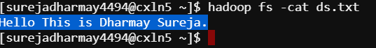

**TASK :- Access the files which you have stored in the HDFS and list out the IP addresses of the nodes of the blocks in which the file is stored, and check its replication factor. Change the Replication factor other than by default you observed and Give a Reason what happens when you Increase and decrease the replication factor of the file stored.**

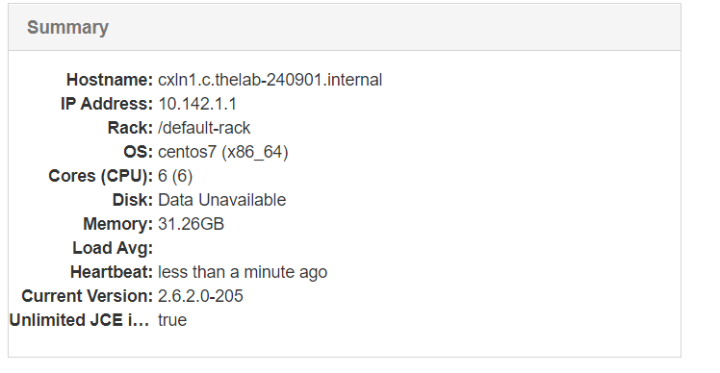

**[ Default Summary ]**

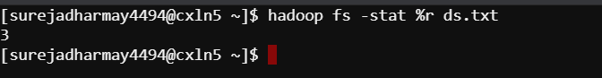

Changing the replication factor to 5

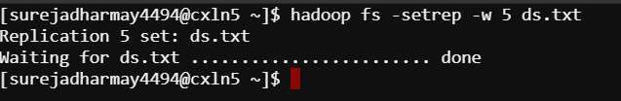

Checking the RF.

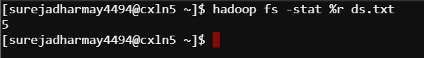

**Reason** : When the replication factor is changed depending upon the increase or decrease of the RF, the copies of the file is made.

**TASK : Perform the following tasks.**

1. Create directory.

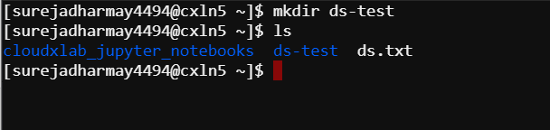

1. Create File

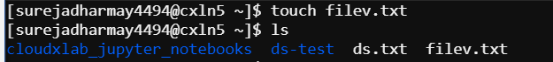

1. Transfer new Created file into created directory .

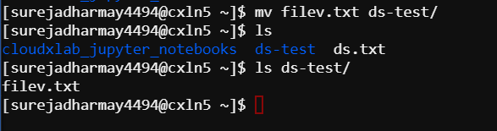

1. Change the replication factor of the file and the whole directory .

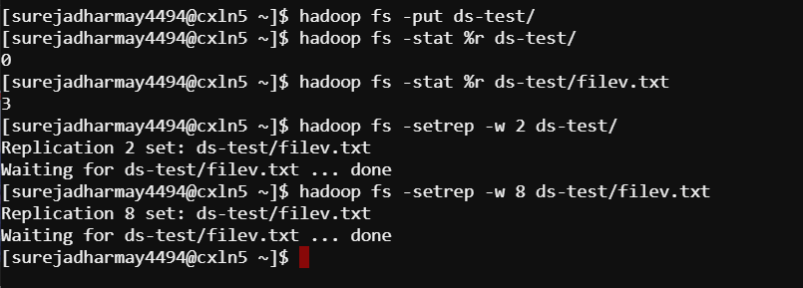

1. Check the list of files and directories in HDFS ( Not in Linux Console ).

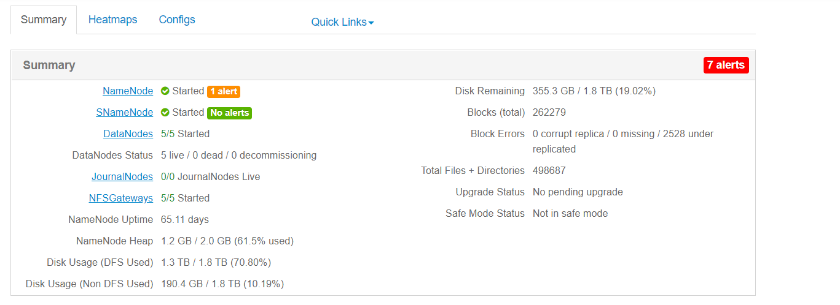

**TASK : Upload the files (at least 2 ) from your local machines to Hadoop cluster console and then Copy it to the HDFS .**

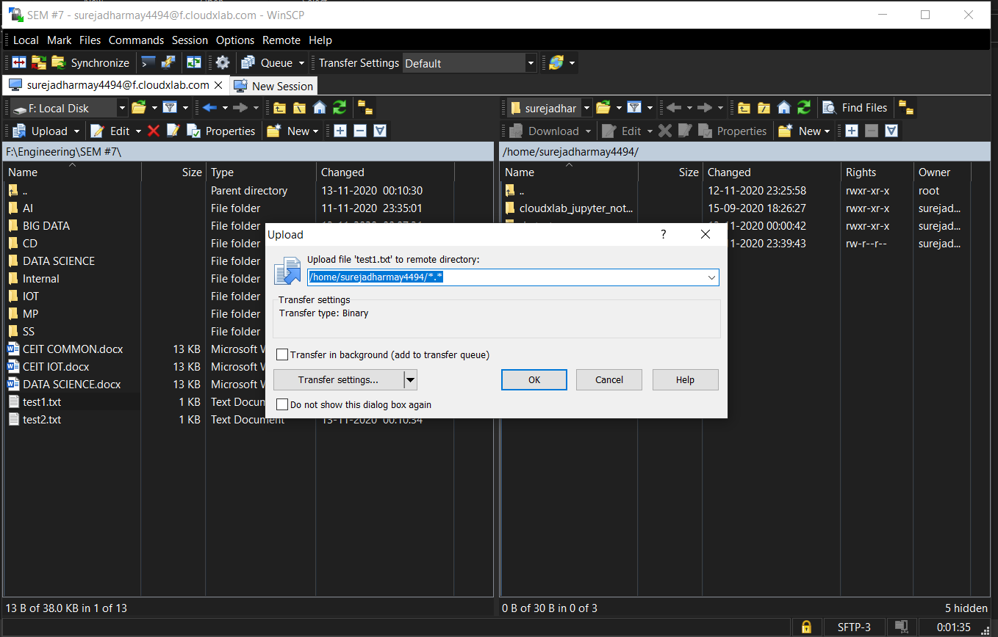

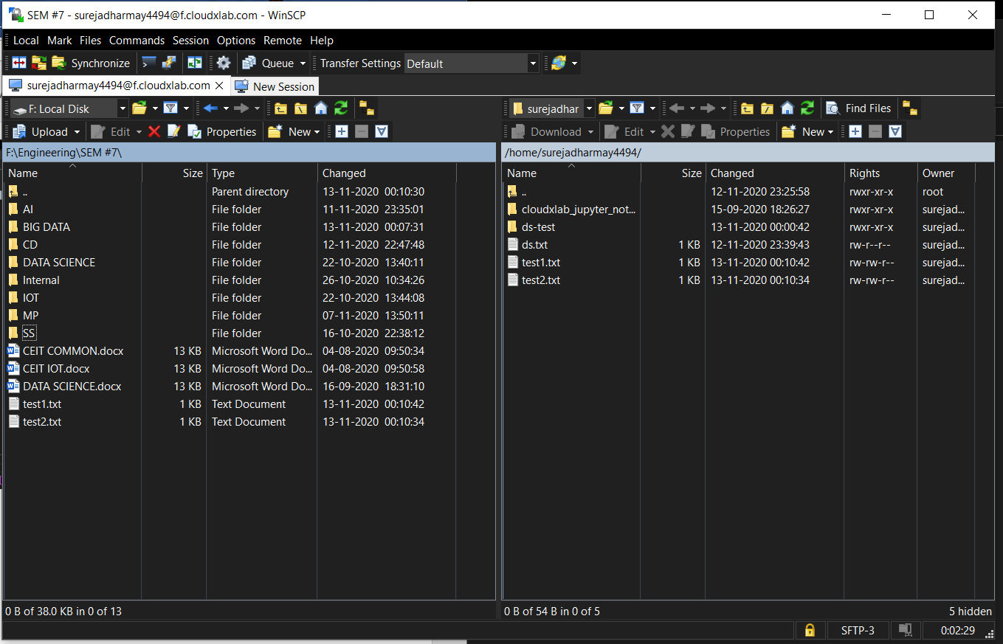

**TASK :- Perform the following commands and write about what output it gives you.**

1. ls – list out the contents

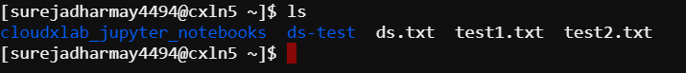

1. pwd – shows the current directory

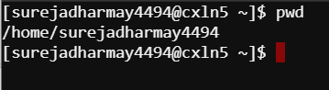

1. help – list out help commands

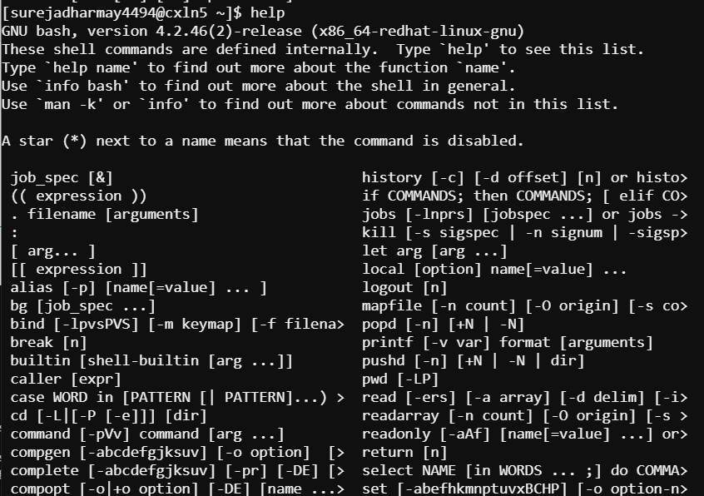

1. ls --la : - list out the contents with extra information

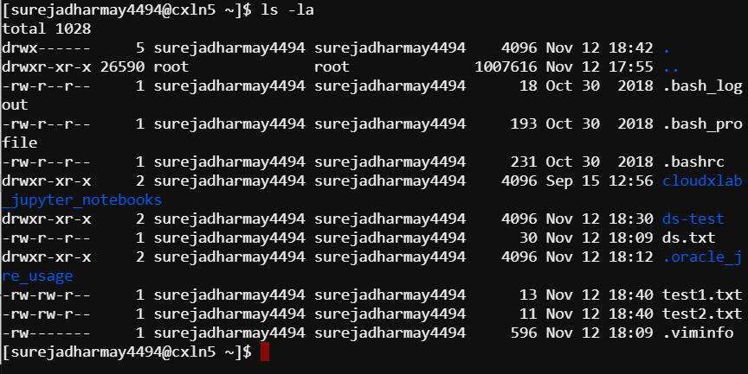

**TASK :- Get the list of all directories and files in the HDFS and Remove the file you created and directories also .**

